**Spike:**  *18*

**Title:** Input Handling

**Author:** Steven Efthimiadis, 1627406

**Goals / deliverables:**

The goal is reconfiguring the input on the keyboard to an inverted style and print a message when you press the keys.

To create this spike, you require:

* Input Handling
* Understanding of input conventions
* Use of the blueprints

**Technologies, Tools, and Resources used:**

List of information needed by someone trying to reproduce this work

* Unreal input handler
  + <https://docs.unrealengine.com/latest/INT/Gameplay/Input/>

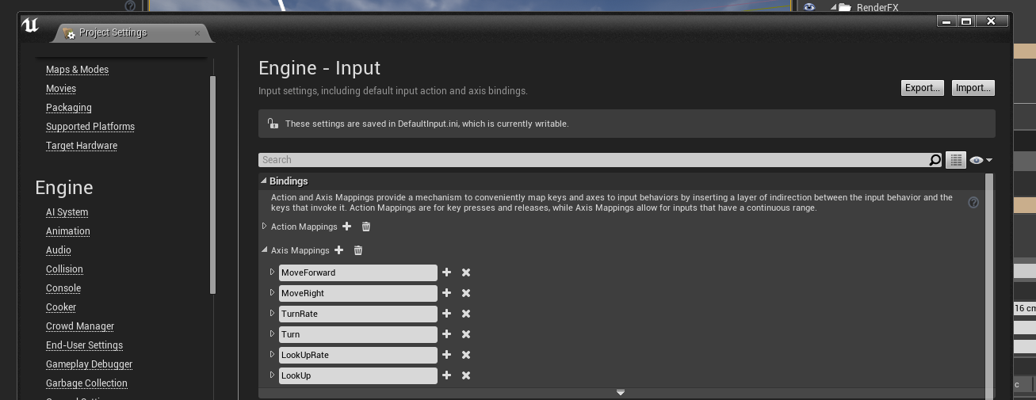**Tasks undertaken:**

* Create a new project with the FPS template
* Edit the input handler
* Edit the blueprint to print a message

**What we found out:**

* For each input axsis. There is a positive and negative value so you don’t have to keep creating unessarery axsis